Open Couplet

🎯 What is Open Couplet
# Source: Chatgpt (GPT-4-turbo) at [8/2/2025]
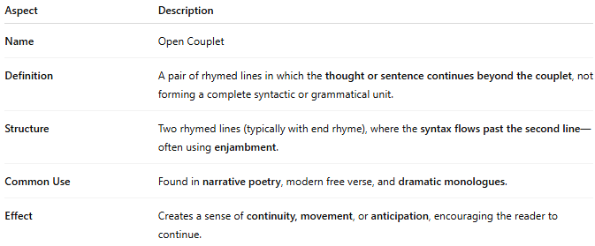
Aspect | Description
Name | Open Couplet
Definition | A pair of rhymed lines in which the thought or sentence continues beyond the couplet, not forming a complete syntactic or grammatical unit.
Structure | Two rhymed lines (typically with end rhyme), where the syntax flows past the second line—often using enjambment.
Common Use | Found in narrative poetry, modern free verse, and dramatic monologues.
Effect | Creates a sense of continuity, movement, or anticipation, encouraging the reader to continue.

✅ Example of an Open Couplet
# Source: Chatgpt (GPT-4-turbo) at [8/2/2025]
I wandered through the silent wood so deep,
Where shadows stretch and whispered secrets sleep
until the moonlight breaks the night in two...
- The rhyme is present ("deep / sleep"), but the thought isn't finished—it spills into the next line.

🧠 Key Insight:
# Source: Chatgpt (GPT-4-turbo) at [8/2/2025]
- Open couplets are not self-contained, unlike closed couplets.
- They are often used in longer poetic passages that develop ideas gradually.

